Experiment 11: Apache Spark Installation and Word Count using PySpark
Title
Installation of Apache Spark and Implementation of Word Count using PySpark DataFrames

Objective
The objective of this experiment is to install and configure Apache Spark on Ubuntu, verify the Spark environment, and perform a Word Count application using PySpark DataFrames. The experiment demonstrates distributed data processing, DataFrame operations, and Spark's parallel computing capabilities for analyzing textual data.

Procedure
Step 1: Update the Ubuntu Package Repository
Update the system packages.
sudo apt update

Step 2: Install Java
Install OpenJDK 21, which is required for Apache Spark.
sudo apt install openjdk-21-jdk -y
Verify the installation.
java -version

Step 3: Configure JAVA_HOME
Open the bash configuration file.
nano ~/.bashrc
Add the following line.
export JAVA_HOME=/usr/lib/jvm/java-21-openjdk-amd64
Reload the configuration.
source ~/.bashrc
Verify.
echo $JAVA_HOME

Step 4: Download Apache Spark
Navigate to the temporary directory.
cd /tmp
Download Spark.
wget https://archive.apache.org/dist/spark/spark-4.1.1/spark-4.1.1-bin-hadoop3.tgz
Extract the archive.
tar -xzf spark-4.1.1-bin-hadoop3.tgz
Move Spark to the installation directory.
sudo mv spark-4.1.1-bin-hadoop3 /opt/spark

Step 5: Configure Spark Environment Variables
Open .bashrc.
nano ~/.bashrc
Add the following lines.
export SPARK_HOME=/opt/spark
export PATH=$PATH:$SPARK_HOME/bin:$SPARK_HOME/sbin
export PYSPARK_PYTHON=/usr/bin/python3
Reload the configuration.
source ~/.bashrc
Verify.
echo $SPARK_HOME

Step 6: Verify Spark Installation
Check Spark version.
spark-shell --version
Launch Spark Shell.
spark-shell
Exit.
:quit

Step 7: Start PySpark
pyspark

Step 8: Create a DataFrame
Create sample data.
data = [
("Hello world Hello Spark",),
("Spark is great for big data",),
("Hello Python and Spark",)
]

df = spark.createDataFrame(data, ["line"])
Display the DataFrame.
df.show()

Step 9: Import Required Libraries
from pyspark.sql.functions import explode, split, col, desc

Step 10: Split Each Line into Individual Words
words_df = df.select(
explode(split(col("line"), " ")).alias("word")
)
Display the words.
words_df.show()

Step 11: Count the Frequency of Each Word
word_counts = words_df.groupBy("word").count()

Step 12: Sort the Words
sorted_word_counts = word_counts.orderBy(desc("count"))

Step 13: Display the Output
sorted_word_counts.show()

Step 14: Create a Text File
Exit PySpark.
exit()
Create a text file.
nano sample.txt
Sample content.
Hello Spark
Spark makes big data easy
Hello Python
Python and Spark
Big Data Analytics
Spark Spark Hello

Step 15: Read the Text File
Start PySpark again.
pyspark
Read the file.
df = spark.read.text("sample.txt")
Display the data.
df.show()

Step 16: Perform Word Count
Import functions.
from pyspark.sql.functions import explode, split, col, desc
Split into words.
words_df = df.select(
explode(split(col("value"), " ")).alias("word")
)
Count words.
word_counts = words_df.groupBy("word").count()
Sort the output.
sorted_word_counts = word_counts.orderBy(desc("count"))
Display the results.
sorted_word_counts.show()

Code
Install Java
sudo apt update

sudo apt install openjdk-21-jdk -y

Configure Java
export JAVA_HOME=/usr/lib/jvm/java-21-openjdk-amd64

source ~/.bashrc

Download Spark
cd /tmp

wget https://archive.apache.org/dist/spark/spark-4.1.1/spark-4.1.1-bin-hadoop3.tgz

tar -xzf spark-4.1.1-bin-hadoop3.tgz

sudo mv spark-4.1.1-bin-hadoop3 /opt/spark

Configure Spark
export SPARK_HOME=/opt/spark

export PATH=$PATH:$SPARK_HOME/bin:$SPARK_HOME/sbin

export PYSPARK_PYTHON=/usr/bin/python3

source ~/.bashrc

Verify Installation
spark-shell --version

spark-shell

Start PySpark
pyspark

Create DataFrame
data = [
("Hello world Hello Spark",),
("Spark is great for big data",),
("Hello Python and Spark",)
]

df = spark.createDataFrame(data, ["line"])

Import Libraries
from pyspark.sql.functions import explode, split, col, desc

Word Count
words_df = df.select(
explode(split(col("line"), " ")).alias("word")
)

word_counts = words_df.groupBy("word").count()

sorted_word_counts = word_counts.orderBy(desc("count"))

sorted_word_counts.show()

Word Count Using File
df = spark.read.text("sample.txt")

words_df = df.select(
explode(split(col("value"), " ")).alias("word")
)

word_counts = words_df.groupBy("word").count()

sorted_word_counts = word_counts.orderBy(desc("count"))

sorted_word_counts.show()

Result
- Successfully installed Apache Spark and configured the required environment variables.
- Verified Spark installation using the Spark Shell and PySpark.
- Created a DataFrame using sample text data.
- Implemented the Word Count application using PySpark DataFrame operations (split, explode, groupBy, and count).
- Successfully performed the same word count operation on a text file, demonstrating Spark's ability to process structured and unstructured data efficiently.
Screen Short: 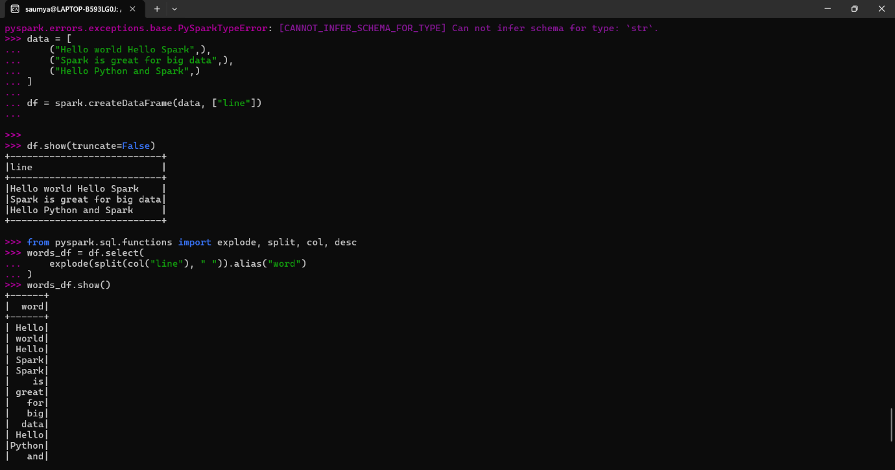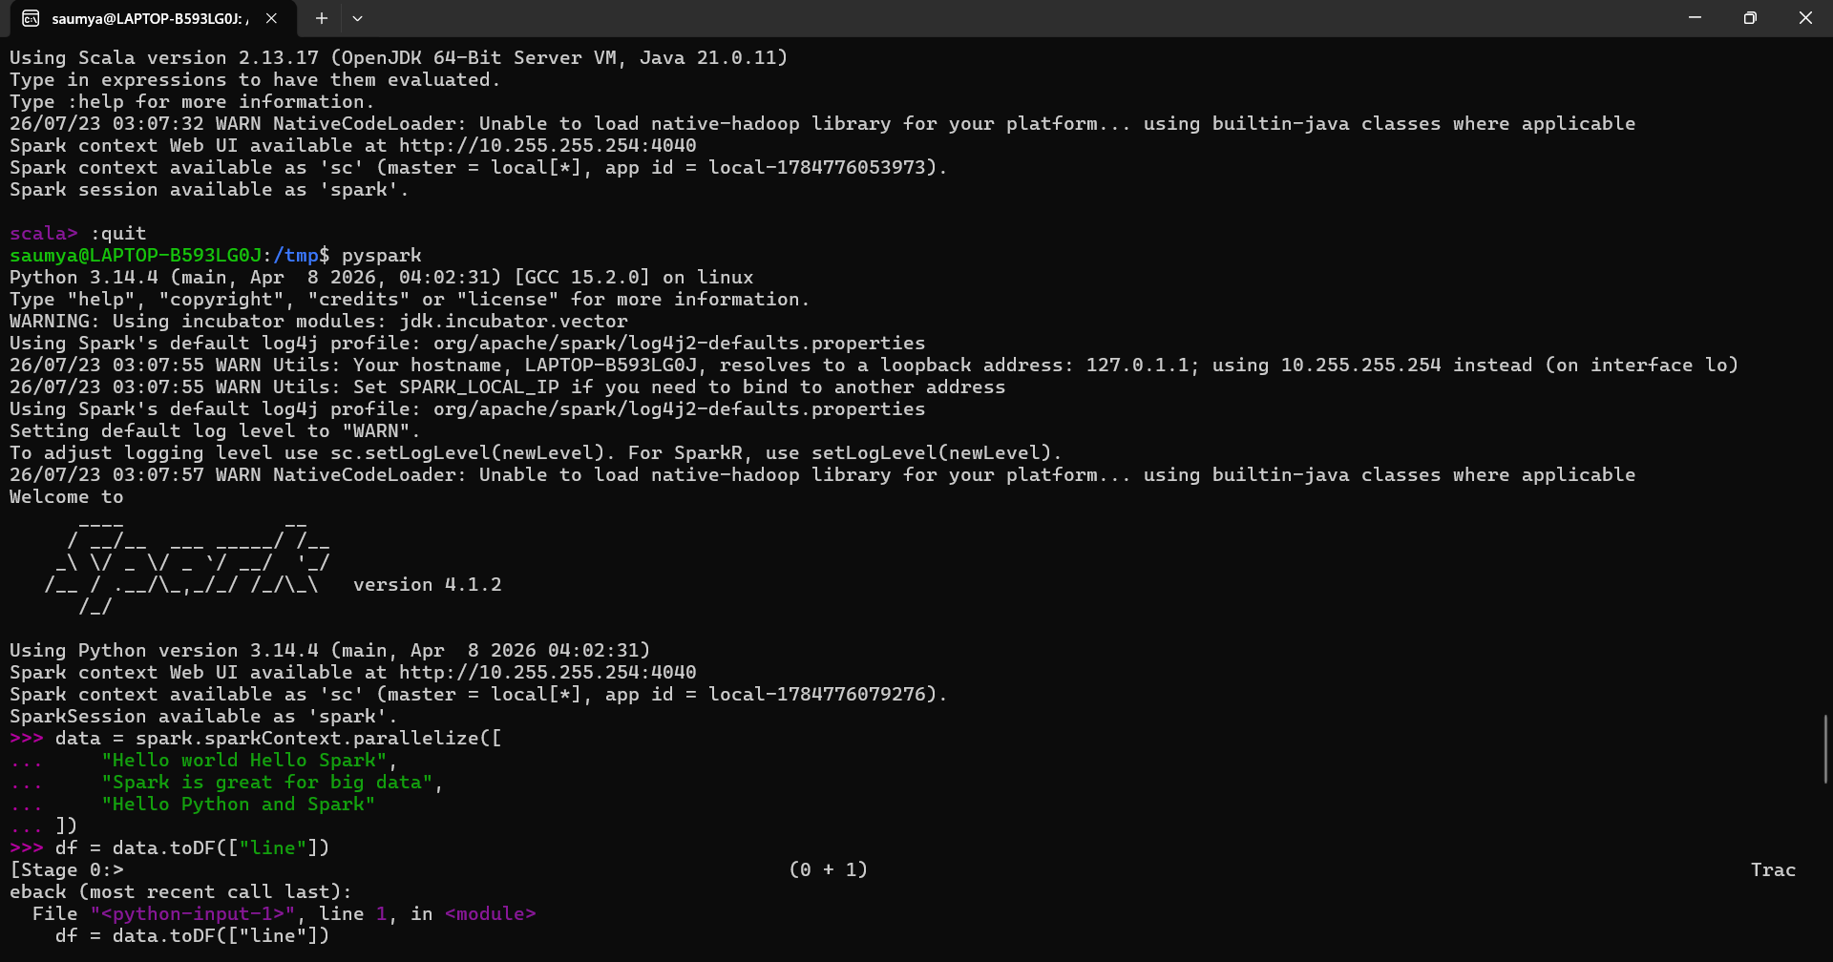
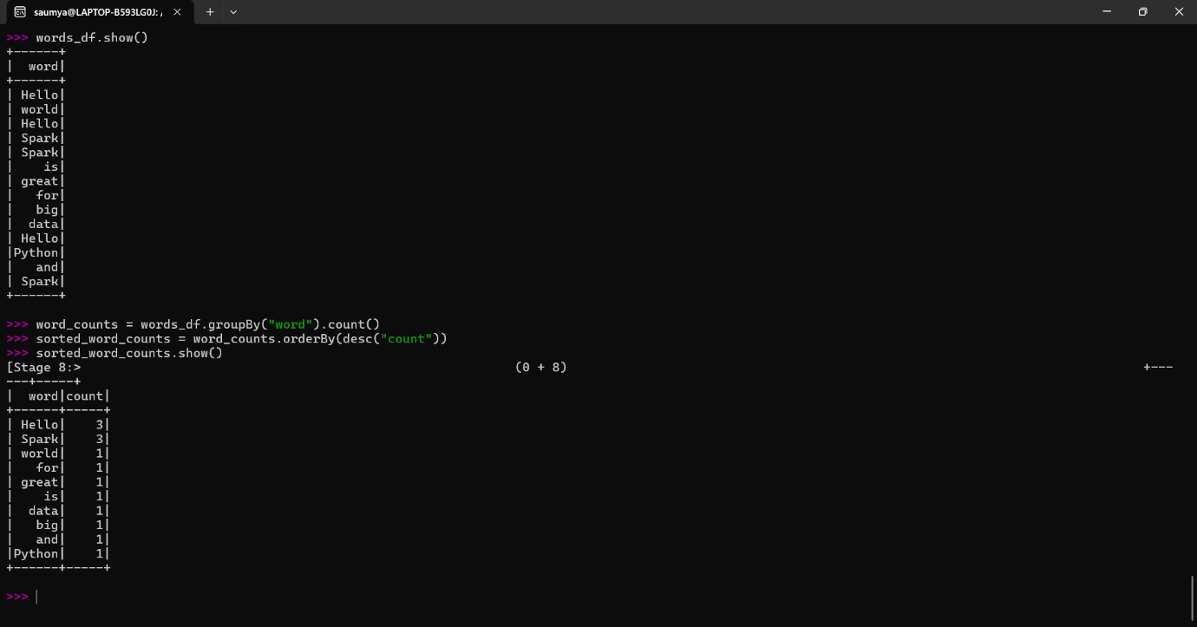
Conclusion
Apache Spark was successfully installed and configured on the Ubuntu system. Using PySpark, a Word Count application was implemented with DataFrames to analyze the frequency of words in both in-memory data and a text file. The experiment demonstrated Spark's distributed processing model, lazy evaluation, and optimized DataFrame API. This highlights Spark's capability to process large datasets efficiently, making it a powerful framework for big data analytics and real-time data processing.

